**SECTION 1 Problem 1**

1. First for the exploratory analysis, the structure of the data set was observed. Following is an outline of the data set.

'data.frame': 110 obs. of 7 variables:

$ ShellType: Factor w/ 2 levels "Type1","Type2": 1 1 1 1 1 1 1 1 1 1 ...

$ Width : num 4.04 3.77 3.86 4.13 4.25 4.16 3.87 3.91 3.99 4.02 ...

$ Length : num 14.4 13.1 13.6 13.9 15.1 ...

$ AperHt : num 3.7 3.54 3.33 3.49 3.99 3.38 3.41 3.95 3.36 3.81 ...

$ AperWdt : num 2.58 2.46 2.06 2.42 2.66 2.08 2.32 2.82 2.78 2.7 ...

$ LU : num 17.9 16.6 16.9 16.8 19 ...

$ LipWdt : num 0.35 0.39 0.32 0.43 0.48 0.5 0.26 0.49 0.26 0.43 ...

This tells us that the dataset has 110 observations and 7 variables. First variable is categorical and the other 6 variables are numerical. Below shows summaries of each numeric variable. To visualize each of them we can use box plot and to see the relationships between them we can use scatterplots.

Width Length AperHt AperWdt

Min. :2.700 Min. : 9.63 Min. :2.400 Min. :1.640

1st Qu.:3.530 1st Qu.:12.88 1st Qu.:3.103 1st Qu.:2.165

Median :3.760 Median :13.79 Median :3.490 Median :2.410

Mean :3.718 Mean :13.94 Mean :3.426 Mean :2.428

3rd Qu.:3.908 3rd Qu.:14.96 3rd Qu.:3.800 3rd Qu.:2.700

Max. :4.280 Max. :18.39 Max. :4.430 Max. :3.180

LU LipWdt

Min. :11.59 Min. :0.1700

1st Qu.:15.96 1st Qu.:0.2800

Median :17.02 Median :0.3300

Mean :17.03 Mean :0.3397

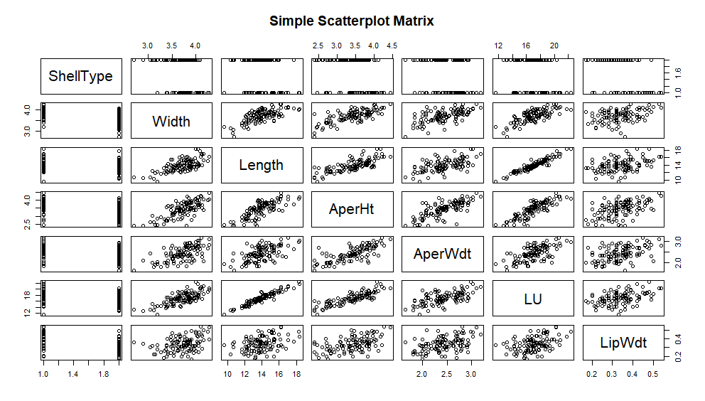 3rd Qu.:18.33 3rd Qu.:0.3800

Max. :22.36 Max. :0.5400

By looking at the Scatterplot, some of the variables clearly shows a linear relation. Namely, Length, AperHt, AperWdt and LU shows strong linear relation.

Another way to see the relationship between variables is to have the Correlation matrix.

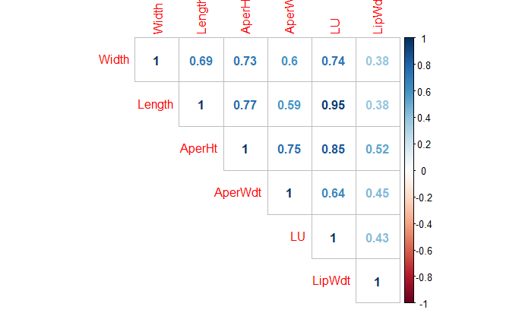

With the Correlation matrix, it is easy to identify which variables have the strongest correlations. Length and LU have the strongest of them and AperHt and LU, Length and AperHt, AperHt and AperWdt, Length and AperHt also seem to have some strong relations.

1. 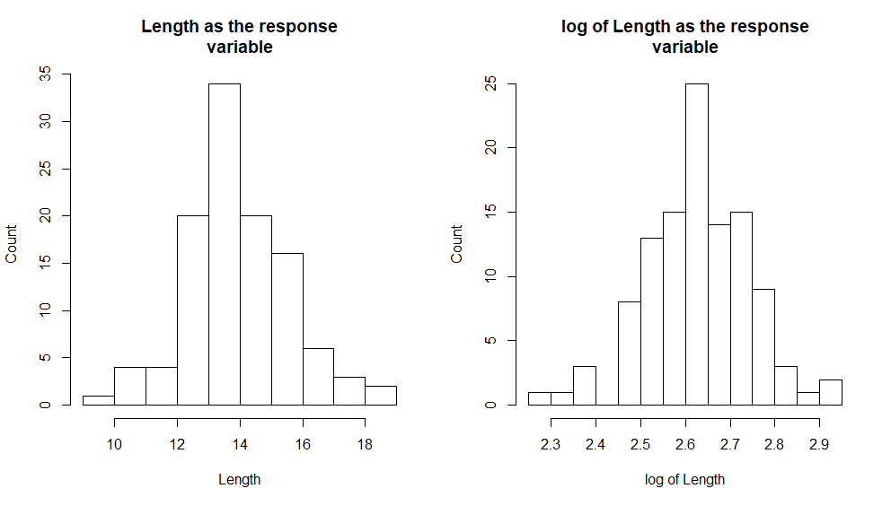To check if Length is appropriate as a response variable, we check whether it fits to a normal distribution. To do that, we look at the histogram of Length and another possible transformation, Log of Length.

As both plots are reasonably symmetric and uni-model, they seem to have normal distribution shape. And since the range of Length variable is from 9.63 to 18.39, we don’t need to have log transformation for Length. Below shows another way to visualize this bell shape using box plots.

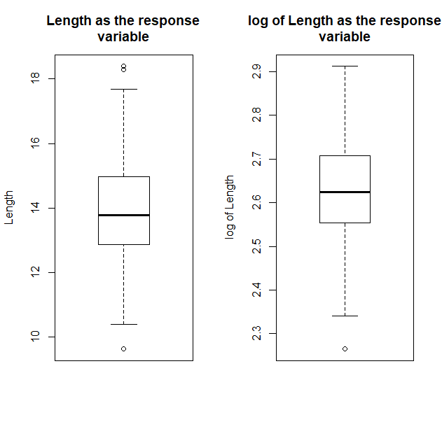

This can be further confirmed by the Shapiro Wilk Test.

$$H_{0} = Variable is normally distributed$$

$$H_{1} = Variable is not normally distributed$$

Shapiro-Wilk normality test

data: Length

W = 0.98854, p-value = 0.4784

Shapiro-Wilk normality test

data: log.Length

W = 0.98825, p-value = 0.456

P-value for Length and log of Length are both close to 0.5. Hence, both variables can be assumed normally distributed and since P-value of Length is more close to 0.5, best out of these two is to choose Length as the respond variable.

1. Simple Linear models were constructed for each of the variables in the data set.

For each of the models the significance of the variable was tested using the t test for variable significance for the following hypothesis.

$$H_{0} = The variable is significant$$

$$H_{1}= The variable is not significant$$

**Model 1** (Length ~ ShellType)

Residuals:

Min 1Q Median 3Q Max

-4.8505 -0.9865 0.0055 0.9195 4.0655

Coefficients:

Estimate Std. Error t value Pr(>|t|)

(Intercept) 14.4805 0.2452 59.059 <2e-16 ***

ShellTypeType2 -0.8660 0.3096 -2.797 0.0061 **

---

Signif. codes: 0 ‘***’ 0.001 ‘**’ 0.01 ‘*’ 0.05 ‘.’ 0.1 ‘ ’ 1

Residual standard error: 1.57 on 108 degrees of freedom

Multiple R-squared: 0.06756, Adjusted R-squared: 0.05893

F-statistic: 7.825 on 1 and 108 DF, p-value: 0.006101

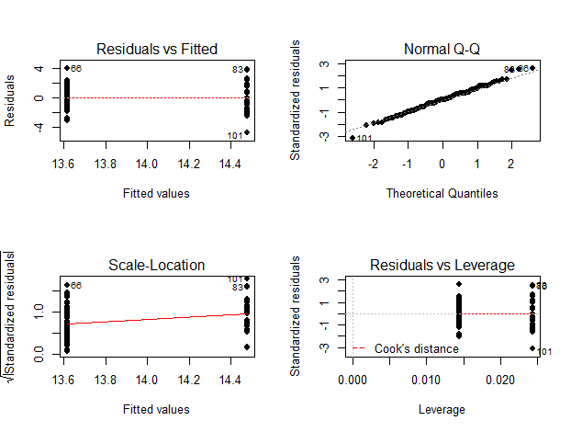The $R^{2}$ of the model is 0.06756 which states that 6.76% of the variation of fitted values of Length variable is explained by ShellType variable which is a categorical variable with two levels. The P value of significance for ShellType is less than 0.05. This concludes that at 0.05 confidence level the variable ShellType is significant for predicting Length Level.

The end points in the QQ plot do not fall on the straight line. Therefore, the plot do not justify the normality assumption.

**Model 2** (Length ~ Width)

Residuals:

Min 1Q Median 3Q Max

-2.3282 -0.8405 -0.0127 0.7662 3.3068

Coefficients:

Estimate Std. Error t value Pr(>|t|)

(Intercept) 0.005743 1.408795 0.004 0.997

Width 3.746866 0.377692 9.920 <2e-16 ***

---

Signif. codes: 0 ‘***’ 0.001 ‘**’ 0.01 ‘*’ 0.05 ‘.’ 0.1 ‘ ’ 1

Residual standard error: 1.176 on 108 degrees of freedom

Multiple R-squared: 0.4768, Adjusted R-squared: 0.4719

F-statistic: 98.42 on 1 and 108 DF, p-value: < 2.2e-16

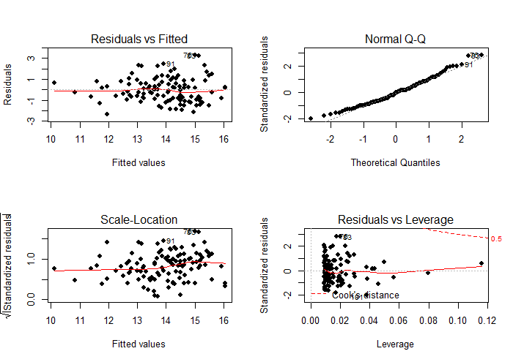The $R^{2}$ of the model is 0.4768 which states that 47.68% of the variation of fitted values of Length variable is explained by Width variable. The P value of significance for Width is less than 0.05. This concludes that at 0.05 confidence level the variable Width is significant for predicting Length Level.

For this model the plot of residuals Vs fitted values does not show any obvious pattern. Also, we can see that the residuals are evenly distributed around the center zero line. Therefore, we can assume that the assumption of Linearity holds for this model. However all the points in the QQ plot do not fall along the straight line. Therefore, we cannot make any assumption on normality.

**Model 3** (Length ~ AperHt)

Residuals:

Min 1Q Median 3Q Max

-1.8489 -0.6294 -0.1706 0.6583 3.0064

Coefficients:

Estimate Std. Error t value Pr(>|t|)

(Intercept) 5.0634 0.7221 7.012 2.13e-10 ***

AperHt 2.5904 0.2088 12.407 < 2e-16 ***

---

Signif. codes: 0 ‘***’ 0.001 ‘**’ 0.01 ‘*’ 0.05 ‘.’ 0.1 ‘ ’ 1

Residual standard error: 1.044 on 108 degrees of freedom

Multiple R-squared: 0.5877, Adjusted R-squared: 0.5839

F-statistic: 153.9 on 1 and 108 DF, p-value: < 2.2e-16

The $R^{2}$ of the model is 0.5877 which states that 58.77% of the variation of fitted values of Length variable is explained by AperHt variable. The P value of significance for AperHt is less than 0.05. This concludes that at 0.05 confidence level the variable AperHt is significant for predicting Length Level.

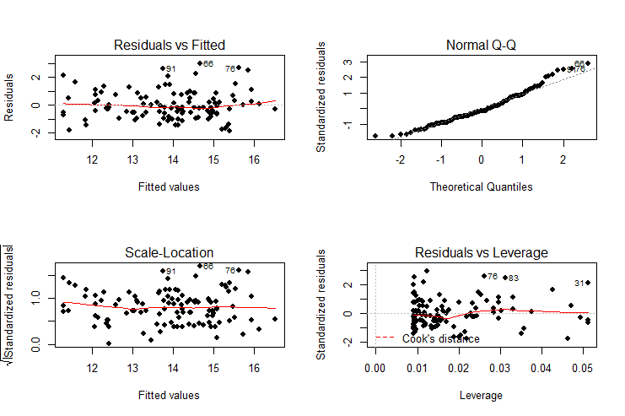Again, in this model, the plot of residuals Vs fitted values does not show any obvious pattern. Also, we can see that the residuals are evenly distributed around the center zero line. Therefore, we can assume that the assumption of Linearity holds for this model. However the end points in the QQ plot do not fall on the straight lin. Therefore, we cannot make any assumption on normality.

**Model 4** (Length ~ AperWdt)

Residuals:

Min 1Q Median 3Q Max

-3.2505 -0.8431 -0.1279 0.8592 3.3895

Coefficients:

Estimate Std. Error t value Pr(>|t|)

(Intercept) 7.1638 0.9079 7.891 2.63e-12 ***

AperWdt 2.7896 0.3703 7.533 1.60e-11 ***

---

Signif. codes: 0 ‘***’ 0.001 ‘**’ 0.01 ‘*’ 0.05 ‘.’ 0.1 ‘ ’ 1

Residual standard error: 1.316 on 108 degrees of freedom

Multiple R-squared: 0.3445, Adjusted R-squared: 0.3384

F-statistic: 56.75 on 1 and 108 DF, p-value: 1.602e-11

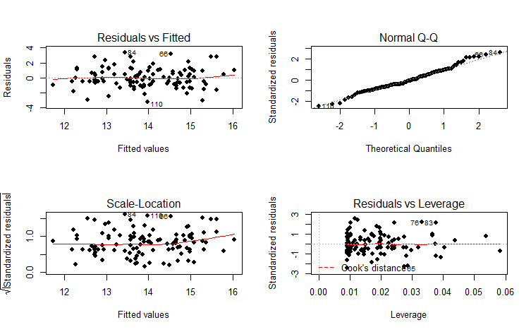The $R^{2}$ of the model is 0.3445 which states that 34.45% of the variation of fitted values of Length variable is explained by AperWdt variable. The P value of significance for AperWdt is less than 0.05. This concludes that at 0.05 confidence level the variable AperWdt is significant for predicting Length Level.

We can see that the residuals are evenly distributed around the center zero line. Therefore, we can assume that the assumption of Linearity holds for this model. However the end points in the QQ plot do not fall on the straight lin. Therefore, we cannot make any assumption on normality.

**Model 5** (Length ~ LU)

Residuals:

Min 1Q Median 3Q Max

-1.74502 -0.28542 -0.01718 0.27650 1.75611

Coefficients:

Estimate Std. Error t value Pr(>|t|)

(Intercept) 0.6430 0.4011 1.603 0.112

LU 0.7808 0.0234 33.369 <2e-16 ***

---

Signif. codes: 0 ‘***’ 0.001 ‘**’ 0.01 ‘*’ 0.05 ‘.’ 0.1 ‘ ’ 1

Residual standard error: 0.4834 on 108 degrees of freedom

Multiple R-squared: 0.9116, Adjusted R-squared: 0.9108

F-statistic: 1114 on 1 and 108 DF, p-value: < 2.2e-16

The $R^{2}$ of the model is 0.9116 which states that 91.16% of the variation of fitted values of Length variable is explained by LU variable. The P value of significance for LU is less than 0.05. This concludes that at 0.05 confidence level the variable LU is significant for predicting Length Level.

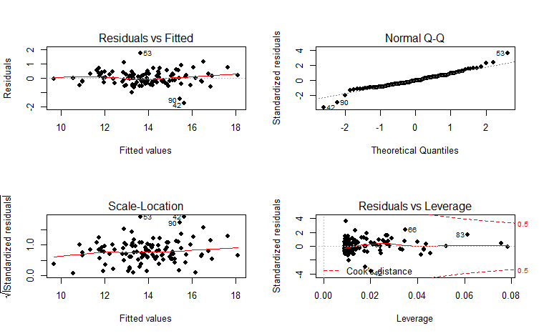the plot of residuals Vs fitted values shows the points fall along the center zero line and evenly scattered around the center line. Therefore, we can assume that the assumption of Linearity holds for this model. However the end points in the QQ plot do not fall on the straight lin. Therefore, we cannot make any assumption on normality.

**Model 6** (Length ~ LipWdt)

Residuals:

Min 1Q Median 3Q Max

-4.2314 -0.9618 -0.0883 0.7516 3.8264

Coefficients:

Estimate Std. Error t value Pr(>|t|)

(Intercept) 11.2864 0.6298 17.922 < 2e-16 ***

LipWdt 7.8029 1.8052 4.322 3.45e-05 ***

---

Signif. codes: 0 ‘***’ 0.001 ‘**’ 0.01 ‘*’ 0.05 ‘.’ 0.1 ‘ ’ 1

Residual standard error: 1.501 on 108 degrees of freedom

Multiple R-squared: 0.1475, Adjusted R-squared: 0.1396

F-statistic: 18.68 on 1 and 108 DF, p-value: 3.448e-05

The $R^{2}$ of the model is 0.1475 which states that 14.75% of the variation of fitted values of Length variable is explained by LipWdt variable. The P value of significance for LipWdt is less than 0.05. This concludes that at 0.05 confidence level the variable LipWdt is significant for predicting Length Level.

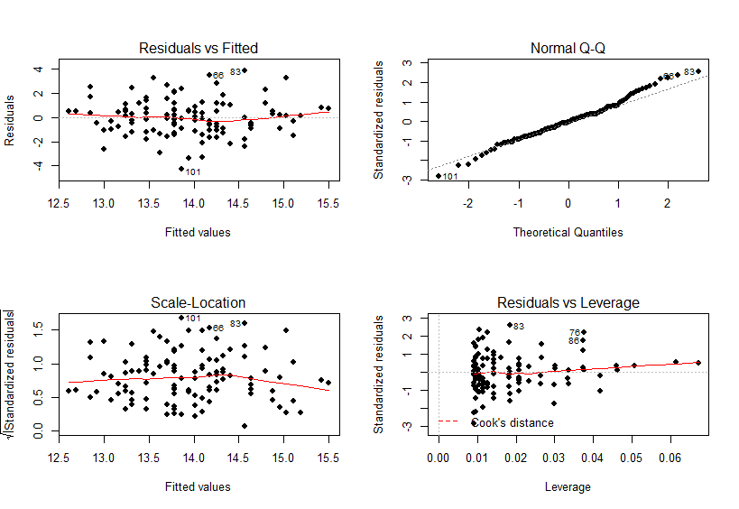For this model the plot of residuals Vs fitted values does not show any obvious pattern. Also, we can see that the residuals are evenly distributed around the center zero line. Therefore, we can assume that the assumption of Linearity holds for this model. However all the points in the QQ plot do not fall along the straight line. Therefore, we cannot make any assumption on normality.

1. A Multiple Regression model was obtained for all the variables.

**Model.ALL**

Residuals:

Min 1Q Median 3Q Max

-1.71415 -0.23723 -0.03966 0.22707 1.95250

Coefficients:

Estimate Std. Error t value Pr(>|t|)

(Intercept) 1.08963 0.64828 1.681 0.0958 .

ShellTypeType2 -0.18429 0.10589 -1.740 0.0848 .

Width -0.09897 0.24115 -0.410 0.6824

AperHt -0.52159 0.21601 -2.415 0.0175 *

AperWdt 0.04369 0.20264 0.216 0.8297

LU 0.89316 0.04562 19.578 <2e-16 ***

LipWdt -0.57332 0.71363 -0.803 0.4236

---

Signif. codes: 0 ‘***’ 0.001 ‘**’ 0.01 ‘*’ 0.05 ‘.’ 0.1 ‘ ’ 1

Residual standard error: 0.4687 on 103 degrees of freedom

Multiple R-squared: 0.9207, Adjusted R-squared: 0.9161

F-statistic: 199.4 on 6 and 103 DF, p-value: < 2.2e-16

The adjusted $R^{2}$ of the model is 0.9161 which states that 91.61% of the variation of fitted values of Length variable is explained by the variables in the model.

Overall F Test

$$H_{0} = All the variables in the model are not associated with Length$$

$$H_{1} = At least one variable in the model is associated with Length$$

The P-value under the overall F test is essentially zero. Therefor we can conclude that at least one of the variables in the model is significant in predicting PSA Level. When the individual P values for the significance of variables are considered only the Variables AperHt and LU have P values less than 0.05 and hence are associated with Length while the other variables under the presence of these significant variables are not associated with Length. Following is the model fitted with these significant variables.

**Model (Length ~ AperHt + LU)**

Residuals:

Min 1Q Median 3Q Max

-1.7881 -0.2713 -0.0476 0.2748 1.8932

Coefficients:

Estimate Std. Error t value Pr(>|t|)

(Intercept) 0.60596 0.38745 1.564 0.12078

AperHt -0.52429 0.17638 -2.972 0.00365 **

LU 0.88850 0.04269 20.813 < 2e-16 ***

---

Signif. codes: 0 ‘***’ 0.001 ‘**’ 0.01 ‘*’ 0.05 ‘.’ 0.1 ‘ ’ 1

Residual standard error: 0.4668 on 107 degrees of freedom

Multiple R-squared: 0.9183, Adjusted R-squared: 0.9168

F-statistic: 601.6 on 2 and 107 DF, p-value: < 2.2e-16

The P value of the overall F test is very low concluding the model significance. It also can be observed that individual P values of all the variables are less than 0.05 concluding all the variables are significant in predicting Length at less than 0.05 significance level.

The nest task is to check for the interactions between ShellType and significant variables. The following is the model with all the interaction terms.

**Model with interactions of ShellType** (Length ~ AperHt + LU + AperHt:ShellType + LU:ShellType)

Residuals:

Min 1Q Median 3Q Max

-1.65580 -0.25051 -0.01991 0.23192 1.84090

Coefficients:

Estimate Std. Error t value Pr(>|t|)

(Intercept) 1.03894 0.40384 2.573 0.01149 *

AperHt -1.15622 0.28510 -4.056 9.63e-05 ***

LU 0.99726 0.05786 17.237 < 2e-16 ***

AperHt:ShellTypeType2 0.97063 0.36668 2.647 0.00937 **

LU:ShellTypeType2 -0.20506 0.07468 -2.746 0.00710 **

---

Signif. codes: 0 ‘***’ 0.001 ‘**’ 0.01 ‘*’ 0.05 ‘.’ 0.1 ‘ ’ 1

Residual standard error: 0.4519 on 105 degrees of freedom

Multiple R-squared: 0.9249, Adjusted R-squared: 0.922

F-statistic: 323.2 on 4 and 105 DF, p-value: < 2.2e-16

The adjusted $R^{2}$ of the model is 0.922 which states that 92.2% of the variation of fitted values of Length variable is explained by the variables in the model. This percentage is bit higher than we observed without interactions. Thus, this is a better model to fit Length.

Analysis of Variance Table

Model 1: Length ~ AperHt + LU

Model 2: Length ~ AperHt + LU + AperHt:ShellType + LU:ShellType

Res.Df RSS Df Sum of Sq F Pr(>F)

1 107 23.315

2 105 21.445 2 1.8701 4.5783 0.01241 *

---

Signif. codes: 0 ‘***’ 0.001 ‘**’ 0.01 ‘*’ 0.05 ‘.’ 0.1 ‘ ’ 1

The P value is less than 0.05. Therefore at 5% significance level we reject the null hypothesis concluding that the model 2 is the better fit.

1. final model is,

$$Length= 1.03894-1.15622*AperHt + 0.99726*LU+0.97063*\left(AperHt*ShellType\right)-0.20506*(LU*ShellType)$$

Considering the interactions, we can note these slops.

$$slop of AperHt=-1.15622+0.97063*ShellType$$

$$slop of LU=0.99726-0.20506*ShellType$$

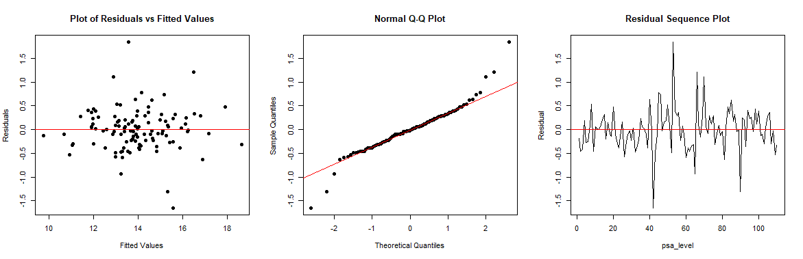

The residuals does not show any obvious pattern and are evenly distributed around the zero line in the plot of residuals Vs fitted values. This provides evidence that the assumptions of homoscedasticity and linearity holds. The normality of the model is questionable from the plot since the end points doesn’t lie on the straight line. Also The Residual sequence plot do not seem to show a completely random pattern. It can be observed that in the middle we can see very sharp spikes to both directions. This indicates that the assumption of independence of error terms might not hold for the model. Apart from this Graphical diagnostics following tests were conducted to further establish these conclusions.

**Shapiro-Wilk normality test**

data: residuals(Model.int)

W = 0.93694, p-value = 5.74e-05

$$H_{0}: The errors are normally distributed.$$

$$H_{1}: The errors are not normally distributed.$$

p-value = 5.74e-05 < 0.05, assumption of the normality of errors terms doesn’t hold at 5% level of significance.

**studentized Breusch-Pagan test**

data: Model.int

BP = 4.684, df = 4, p-value = 0.3213

$$H_{0}: The errors have constant variance.$$

$$H_{1}: The errors do not have constant variance.$$

p-value = 0.3213 > 0.05, the assumption of the constant variance of errors hold at 5% level of significance.

**Durbin-Watson test**

data: Model.int

DW = 1.7817, p-value = 0.08951

alternative hypothesis: true autocorrelation is greater than 0

d = 1.7817. this value is closer to 2. This indicates that the residuals are independent.

1. The fitted value for Length when the quantitative variables are at their mean levels and the qualitative variable, ShellType, is Type1 and Type2 are as follows.

> Length.Type1

1

**14.05715**

> Length.Type2

1

**13.89095**

**SECTION 2 Problem 1**

# Importing the dataset

train.data <- read.csv(file.choose(), header = T)

attach(train.data)

a)

# Visualizing the structure of the dataset

str(train.data)

summary(train.data[,-1]) # removing categorical variable

# Scatterplot of the variables

pairs(~ + ShellType + Width + Length + AperHt + AperWdt + LU + LipWdt, data=train.data, main="Simple Scatterplot Matrix")

# Plotting correlation plot between PSA Level and other variables

install.packages("corrplot")

library(corrplot)

M <- cor(train.data [,-1]) # removing categorical variable

corrplot(M, type="upper", method="number")

b)

#checking whether the response variable Length approximately follow normal

distribution

log.Length <- log(Length)

# Histograms of Length and log of Length

par(mfrow = c(1, 2))

hist(Length, main="Length as the response

variable", breaks=10, xlab="Length", ylab="Count")

hist(log.Length, main="log of Length as the response

variable", breaks=10, xlab="log of Length", ylab="Count")

# Box plots of Length and log of Length

par(mfrow = c(1, 2))

boxplot(train.data$Length, main="Length as the response

variable", ylab="Length")

boxplot(log.Length, main="log of Length as the response

variable", ylab="log of Length")

c)

# Fitting Linear regression models for the respond variable with others

Model.ShellType = lm(Length~ShellType, data=train.data)

summary(Model.ShellType)

par(mfrow = c(2, 2))

plot(Model.ShellType, pch = 19)

Model.Width = lm(Length~Width, data=train.data)

summary(Model.Width)

par(mfrow = c(2, 2))

plot(Model.Width, pch = 19)

Model.AperHt = lm(Length~AperHt, data=train.data)

summary(Model.AperHt)

par(mfrow = c(2, 2))

plot(Model.AperHt, pch = 19)

Model.AperWdt = lm(Length~AperWdt, data=train.data)

summary(Model.AperWdt)

par(mfrow = c(2, 2))

plot(Model.AperWdt, pch = 19)

Model.LU = lm(Length~LU, data=train.data)

summary(Model.LU)

par(mfrow = c(2, 2))

plot(Model.LU, pch = 19)

Model.LipWdt = lm(Length~LipWdt, data=train.data)

summary(Model.LipWdt)

par(mfrow = c(2, 2))

plot(Model.LipWdt, pch = 19)

d)

# Fitting a multiple linear regression model using all the predictor variables

Model.All = lm(Length ~. , data=train.data)

summary(Model.All)

# Fitting a multiple linear regression model using only the significant variables

Model.droped = lm(Length ~ + AperHt + LU , data=train.data)

summary(Model.droped)

e)

Model.int=lm(Length ~ AperHt + LU + AperHt:ShellType + LU:ShellType, data=train.data)

summary(Model.int)

anova(Model.droped, Model.int)

f)

par(mfrow = c(1, 3))

# Plot of residuals vs fitted for main effects only model

plot(fitted(Model.int), residuals(Model.int), pch = 19, xlab = "Fitted Values", ylab = "Residuals", main = "Plot of Residuals vs Fitted Values")

abline(h = 0, col = "red")

# Normal Q-Q plot

qqnorm(residuals(Model.int), pch = 19, main = "Normal Q-Q Plot")

qqline(residuals(Model.int), col = "red")

# Residual sequential plot to check the independence of residuals

plot(residuals(Model.int), xlab = "psa_level", ylab = "Residual", main="Residual Sequence Plot", type = "l")

abline(h = 0, col = "red")

# Normality test: Shapiro-Wilk normality test

shapiro.test(residuals(Model.int))

# Constant variance: Breusch-Pagan test

library(lmtest)

bptest(Model.int)

# Durbin-Watson test to check whether residuals are uncorrelated

dwtest(Model.int)

g)

# predicting Length with ShellType = ShellType1

newdata1 <- data.frame(ShellType=factor("Type1", levels=c("Type1", "Type2")), AperHt=mean(AperHt), LU=mean(LU))

Length.Type1 = predict(Model.int, newdata1)

# predicting Length with ShellType = ShellType2

newdata2 <- data.frame(ShellType=factor("Type2", levels=c("Type1", "Type2")), AperHt=mean(AperHt), LU=mean(LU))

Length.Type2 = predict(Model.int, newdata2)